Business Plan Template

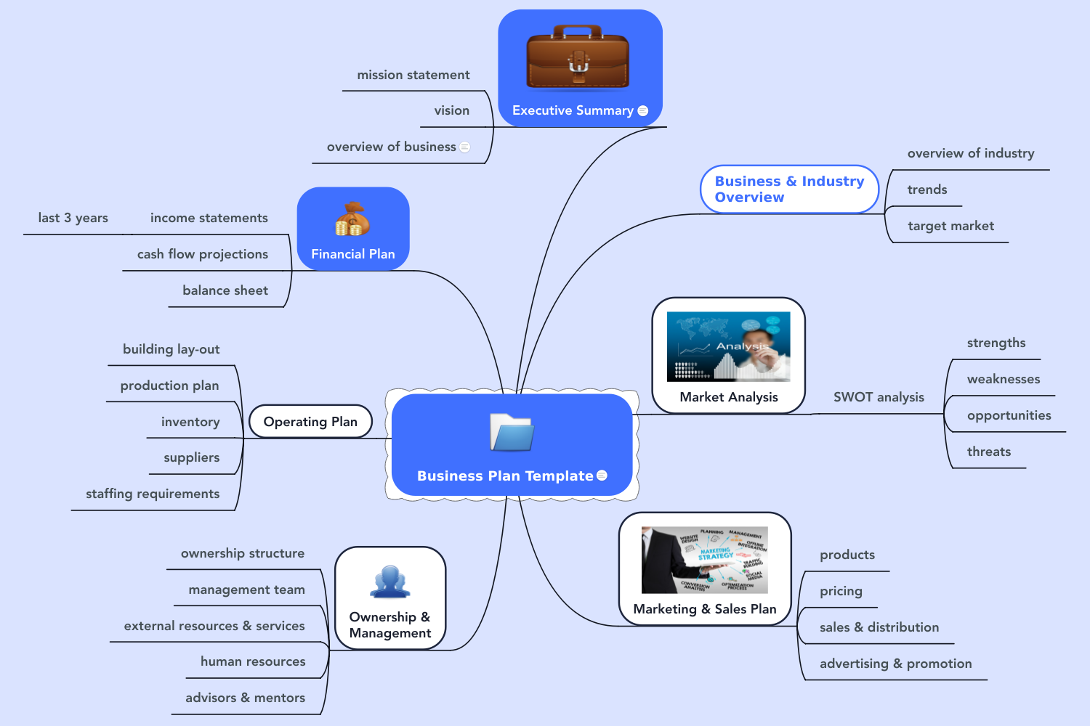

Contents
1 Executive Summary 4
1.1 mission statement 4
1.2 vision 4
1.3 overview of business 4
2 Business & Industry Overview 5
2.1 overview of industry 5
2.2 trends 5
2.3 target market 5
3 Market Analysis 6
3.1 SWOT analysis 6
3.1.1 strengths 6
3.1.2 weaknesses 6
3.1.3 opportunities 6
3.1.4 threats 6
4 Marketing & Sales Plan 7
4.1 products 7
4.2 pricing 7
4.3 sales & distribution 7
4.4 advertising & promotion 7
5 Ownership & Management 8
5.1 ownership structure 8
5.2 management team 8
5.3 external resources & services ..………………………………………………………………………………..11
5.4 human resources …………………………………………………………………………………………………….11
5.5 advisors & mentors ………………………………………………………………………………………………….11
6 Operating Plan 9
6.1 building lay-out 9
6.2 production plan 9
6.3 inventory 9
6.4 suppliers 9
6.5 staffing requirements…………………………………………………………………………………….………..12
7 Financial Plan 10
7.1 income statements 10
7.1.1 last 3 years 10
7.2 cash flow projections 10
7.3 balance sheet 10

Executive Summary
This section is usually completed last, as you will gain insights for this summary as you go through the different components of your business plan. Your executive summary should be concise (1 page) and provides an optimistic overview of your business.

mission statement – what is the need for your business; why does it exist – who, what, why?

vision – what do you want your business to be and achieve in the long term? What are your goals for the future and how will you get there?

overview of business – brief outline of the management and ownership of your business. Include description of your main product and service offerings, along with description of your customer. State your competitive advantage and financial projections for next 3 years.

Business & Industry Overview

overview of industry – include market demographics, economical and governmental influences.

trends – consider consumer habits and preferences. Look at how your industry started in the market, how it has grown, and where it is expected to go.

target market – who is your ideal customer? Describe your customer who will need and is most likely to buy your product or service?

Market Analysis
You may include market research to help determine how suitable a particular market is for your industry.

SWOT analysis

strengths – what are the characteristics within your business that are an advantage when compared to other, similar businesses – consider financial resources, human resources, facilities, equipment and processes.

weaknesses – what are the characteristics within your business that are a disadvantage when compared to other, similar businesses.

opportunities – consider favourable, external influences that give your business a competitive advantage.

threats – consider external influences that have the potential to negatively impact your business.

(see the resources page on our website for a SWOT template with notes to help you in completing a SWOT analysis – www.malabargroup.ca)

Marketing & Sales Plan
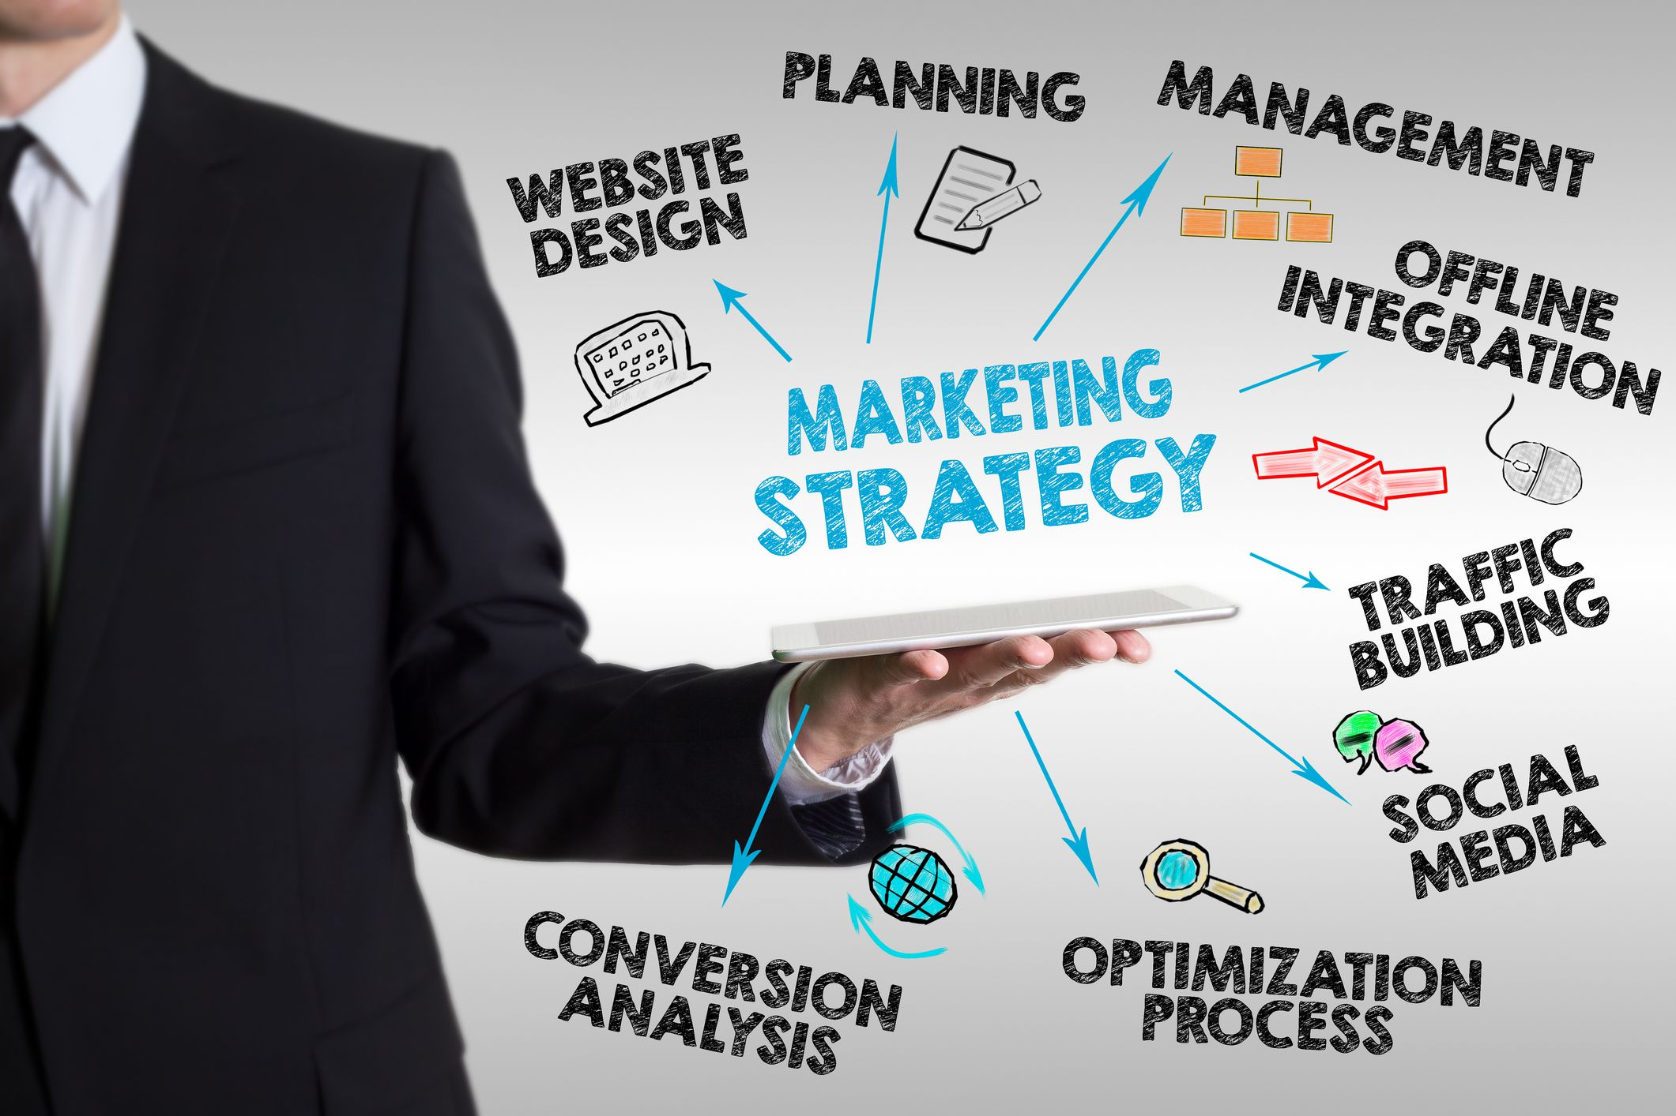
Where and how will you get your customers?

products – describe the features, advantages and benefits of buying your product or service.

pricing - How do you intend to price your product/service? Know the actual cost (including labour, and the overall business costs to carry the product/service) and include consideration for price discounts, payment arrangements, credit terms.

sales & distribution – how will you sell your product/service? What are your revenue targets for the next year, and what are the specific actions your team will take to reach those targets? Distribution is how will your product/service be made available to your customer?

advertising & promotion – tools you will use to get more customers – personal selling, sales promotions, publicity, sponsorships, social media.

Ownership & Management

Ownership structure – describe the legal structure of your business (corporation, sole proprietor, partnership?), include overview of share ownership.

Management team – provide details including key employee positions, overview of responsibilities, and their salary/compensation. May also include their resumes.

External Resources & Services – list any external professional support including accountants, lawyers, consultants, contractors.

Human Resources – provide a list of employees and job titles including salary and benefits.

Advisors & Mentors – do you have an advisory board or mentors to support management?

Operating Plan
(fill in where applicable to your business)

building lay-out - describe the type, site and location of your business and include drawings if available. You can also include a description of key pieces of production equipment with their costs.

production plan – may include your manufacturing process – how your product or service will be made and how long does it take to produce? Do you have quality control measures in place and if so, what are they?

inventory – how do you keep track of inventory? Cycle counts, annual inventory audit? What inventory cost method do you use – LIFO (last-in-first-out) or FIFO (first-in-first-out)?

suppliers – who are your suppliers – include their prices, terms and conditions. Do you have a secondary supplier for each in case these suppliers are unable to fill your orders?

staffing requirements – key personnel, skills, training needs

Financial Plan
Take a look at your numbers – what are your monthly fixed expenses? How much does it cost to make your product or provide your service? What is your gross profit %? What is your break-even? Are there any new assets (equipment) and technology that you need to purchase?

income statements – this report outlines how much money you’ve taken in for the business, where the money came from, what your expenses were, and your net income after all expenses are paid. Include your income statement for the most recent year, and also an income statement (proforma) forecast for the upcoming year.

last 3 years – create a comparative income statement for the last 3 years. This will provide you with a snapshot of your business trends for sales, for your highest expenses, and your profit margins.

cash flow projections – this will show you if, and when you will run out of cash essential to the operation of your business. This allows you to take action before serious problems occur.

balance sheet – this financial report lists the type and value of all of your business assets and liabilities, and the ownership interest (who owns what in the company).

Suggested Additional Resources;
Websites; www.bplans.com
Software program; www.liveplan.com (online software program to do your business plan and includes financial tools – monthly subscription required)
Book; The Plan-As-You-Go Business Plan by Tim Berry (available on Amazon)

